Cybersecurity Analyst Internship
Task Report

[samfelix15@gmail.com]
Task No: [6 - Firewall Configuration]

Copyright © 2024 EncryptEdge Labs. All rights reserved
Credit: Offensive Security

Table of Contents a
1.0 EncryptEdge Labs Internship Task Report 2
1.1 Introduction 3
1.2 Objective 4
1.3 Requirements 4
2.0 High-Level Summary 5
2.1 Recommendations 10
2.2 Risk exposure over time 11
3.0 Report - Methodologies 11
3.1 Information Gathering 12
4.0 Additional Items
4.1 Recommendations and Screenshots 13

1.0 EncryptEdge Labs Internship Task Report
1.1 Introduction
Firewall configuration is a vital component of network security, serving as a barrier between trusted and untrusted networks. A properly configured firewall prevents unauthorized access, blocks malicious traffic, and protects sensitive data. To configure a firewall effectively, it is essential to define a clear security policy, outlining the types of traffic allowed to pass through the firewall.
Firewall rules are created based on this policy, defining the specific conditions under which traffic is allowed or blocked. These rules can be based on various criteria, including source and destination IP addresses, ports, protocols, and packet contents. The principle of least privilege should be followed, allowing only necessary traffic to pass through the firewall.
Network segmentation is also crucial, with different areas of the network designated as zones, each with its own unique security requirements. This targeted approach enables administrators to apply specific security policies and reduce the attack surface. Regular testing and monitoring are necessary to ensure the effectiveness of the firewall configuration and identify potential vulnerabilities.

1.2 Objective
Understand the fundamentals of firewalls, including their purpose, types and common deployment scenarios.
Learn about packet filtering and stateful effective firewalls
Gain hands on experience by setting a virtual network in cisco packet tracer, configuring a firewall, and implementing traffic control rules.

1.3 Requirements
Effective firewall configuration requires a comprehensive understanding of network security principles, firewall technologies, and configuration best practices. The following requirements must be met:
A clear security policy must be defined, outlining the types of traffic allowed to pass through the firewall. Firewall rules must be created based on this policy, defining the specific conditions under which traffic is allowed or blocked. Network segmentation is crucial, with different areas of the network designated as zones, each with its own unique security requirements. Regular testing and monitoring are necessary to ensure the effectiveness of the firewall configuration and identify potential vulnerabilities.
In this report, the required tools include
Cisco Packet Tracer and Awesome Web Application Firewall (W A F).

Types of Firewalls in System Security:
Firewalls are a crucial component of system security, acting as a barrier between trusted and untrusted networks. There are several types of firewalls, each with its own unique characteristics, advantages, and disadvantages. In this explanation, we will delve into the different types of firewalls, exploring their features, functionality, practical applications, and benefits.
Network-Based Firewalls:
Network-based firewalls are installed on network devices, such as routers or switches, and filter traffic between networks. They operate at the network layer of the OSI model and are designed to protect entire networks from external threats.
Examples:
Cisco ASA (Adaptive Security Appliance)
Juniper SRX (Security Services Gateway)
Practical Applications:
- Protecting enterprise networks from external threats
- Segmenting networks into different zones, each with its own unique security requirements
Benefits:
- Protects entire networks from external threats
- Can be configured to filter traffic based on source and destination IP addresses, ports, and protocols
- Can be used to segment networks into different zones, each with its own unique security requirements
2. Host-Based Firewalls:
Host-based firewalls are installed on individual hosts and control incoming and outgoing traffic. They operate at the application layer of the OSI model and are designed to protect individual hosts from external threats.
Examples:
Windows Defender Firewall (formerly Windows Firewall)
macOS Firewall
Practical Applications
Protecting individual hosts from external threats
- Controlling incoming and outgoing traffic on individual hosts
Benefits:
Provides detailed logging and reporting capabilities
Can be configured to filter traffic based on specific applications and services
Can be used to protect individual hosts from internal threats
3. Application Firewalls:
Application firewalls are designed to protect specific applications and services from external threats. They operate at the application layer of the OSI model and are designed to filter traffic based on specific application protocols.
Examples:
Web Application Firewalls (WAFs)
Database Firewalls
Practical Applications:
- Protecting web applications from external threats
- Protecting databases from external threats
Benefits:
Provides detailed logging and reporting capabilities
Can be configured to filter traffic based on specific application protocols
Can be used to protect specific applications and services from internal threats
4. Next-Generation Firewalls (NGFWs):
NGFWs are designed to provide advanced security features, including intrusion prevention, application control, and SSL inspection. They operate at the application layer of the OSI model and are designed to filter traffic based on specific application protocols.
Examples:
Palo Alto Networks Next-Generation Firewall
Check Point Next-Generation Firewall
Practical Applications:
Protecting enterprise networks from advanced threats
Providing application control and visibility
Benefits:
Provides advanced security features, including intrusion prevention and application control
Can be configured to filter traffic based on specific application protocols
Provides detailed logging and reporting capabilities
5. Software Firewalls
Software firewalls are installed on individual hosts and control incoming and outgoing traffic. They operate at the application layer of the OSI model and are designed to protect individual hosts from external threats.
Examples:
Windows Defender Firewall (formerly Windows Firewall)
macOS Firewall
Practical Applications
Protecting individual hosts from external threats
Controlling incoming and outgoing traffic on individual hosts
Benefits:
Provides detailed logging and reporting capabilities
Can be configured to filter traffic based on specific applications and services
Can be used to protect individual hosts from internal threats
6. Hardware Firewalls:
Hardware firewalls are installed on network devices, such as routers or switches, and filter traffic between networks. They operate at the network layer of the OSI model and are designed to protect entire networks from external threats.
Examples:
Cisco ASA (Adaptive Security Appliance)
Juniper SRX (Security Services Gateway)
Practical Applications:
Protecting enterprise networks from external threats
Segmenting networks into different zones, each with its own unique security requirements
Benefits:
Protects entire networks from external threats
Can be configured to filter traffic based on source and destination IP addresses, ports, and protocols
- Can be used to segment networks into different zones, each with its own unique security requirements

2.0 High-Level Summary
In conclusion, firewalls are a crucial component of system security, and there are several types of firewalls to choose from, each with its own unique characteristics, advantages, and disadvantages. By understanding the different types of firewalls, organizations can select the most appropriate firewall solution to meet their specific security requirements. ‎
Effective firewall configuration requires a comprehensive understanding of network security principles, firewall technologies, and configuration best practices. The following requirements must be met:
A clear security policy must be defined, outlining the types of traffic allowed to pass through the firewall. Firewall rules must be created based on this policy for example access control list, defining the specific conditions under which traffic is allowed or blocked. Network segmentation is crucial, with different areas of the network designated as zones, each with its own unique security requirements. Regular testing and monitoring are necessary to ensure the effectiveness of the firewall configuration and identify potential vulnerabilities.

2.1 Recommendations
To ensure effective firewall configuration, we recommend the following:
Conduct a thorough risk assessment to identify potential vulnerabilities and threats. Implement a layered security approach, combining firewall configuration with other security measures, such as intrusion detection and prevention systems. Regularly review and update firewall rules to ensure they remain effective and aligned with changing network requirements. Provide ongoing training and support for network administrators to ensure they have the necessary skills and knowledge to configure and manage firewalls effectively.

2.2 Risk Exposure over Time
The risk exposure associated with firewall configuration can vary over time. Initially, the risk may be high due to the potential for misconfiguration or inadequate security policies. However, as the firewall configuration is regularly reviewed and updated, the risk exposure can decrease. Conversely, if the firewall configuration is not regularly maintained, the risk exposure can increase over time, as new vulnerabilities and threats emerge.

3.0 Methodologies
To configure a firewall effectively, the following methodology can be followed:
Define a clear security policy, outlining the types of traffic allowed to pass through the firewall. Conduct a thorough risk assessment to identify potential vulnerabilities and threats. Design and implement a layered security approach, combining firewall configuration with other security measures. Configure firewall rules based on the security policy, defining the specific conditions under which traffic is allowed or blocked. Regularly review and update firewall rules to ensure they remain effective and aligned with changing network requirements. Provide ongoing training and support for network administrators to ensure they have the necessary skills and knowledge to configure and manage firewalls effectively

3.1 Information Gathering
With respect to this report, information was accumulated and gathered based on persona l gained knowledge, articles, journals and related URLs,videos and live labs provided by EncryptedgeLabs. These includes
- Understanding Firewalls-Firewall Guide
- How Firewall Works-Firewall Basics
- A comprehensive guide to setting up a firewall

4.0 Additional Items
4.1 Recommendations And Screenshots
Best Recommendations for Optimizing Firewall Configuration:
1. Simplify and Consolidate Rules: Regularly review and consolidate rules to reduce complexity and improve performance.
2. Implement a Zero-Trust Approach: Assume all traffic is untrusted and require strict authentication and authorization.
3. Use Object-Based Configuration: Use objects to represent networks, services, and users, making it easier to manage and update rules.
4. Leverage Advanced Security Features: Utilize features like intrusion prevention, application control, and SSL inspection to enhance security.
5. Regularly Update and Patch: Ensure the firewall and its components are up-to-date with the latest security patches and updates.
6. Monitor and Analyze Traffic: Continuously monitor and analyze traffic to identify potential security threats and optimize firewall rules.
7. Implement a Change Management Process: Establish a formal change management process to ensure all changes to the firewall configuration are properly reviewed, tested, and approved.

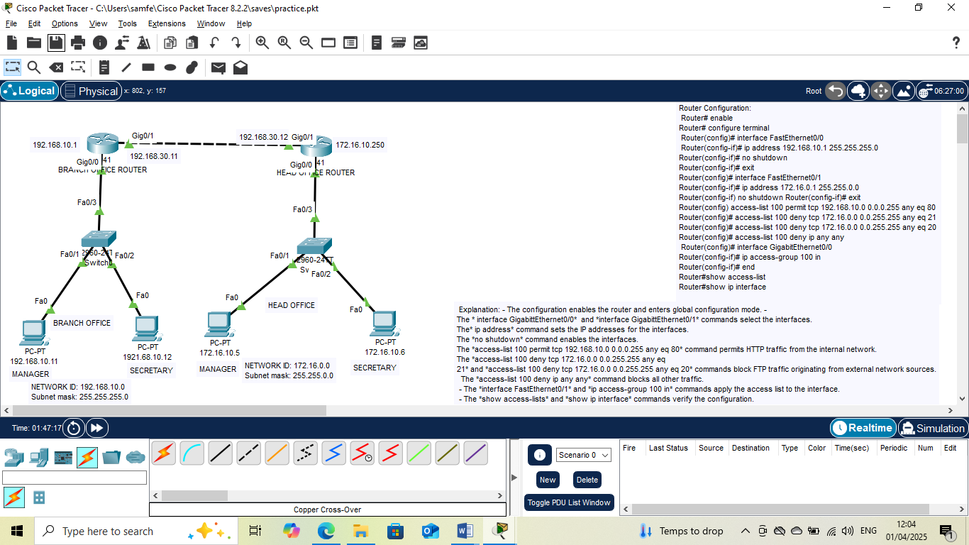

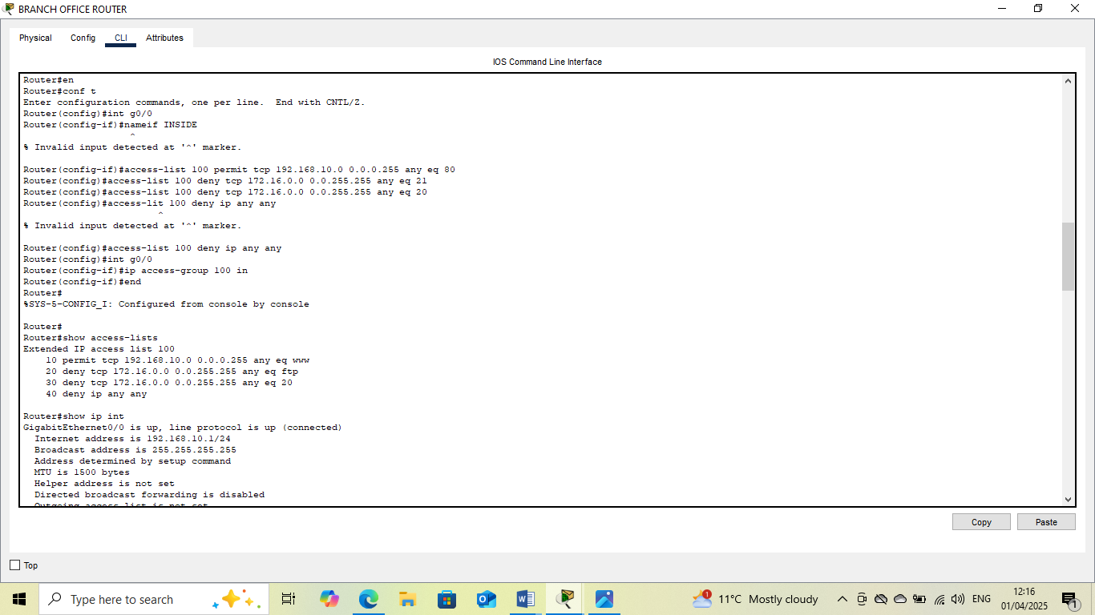
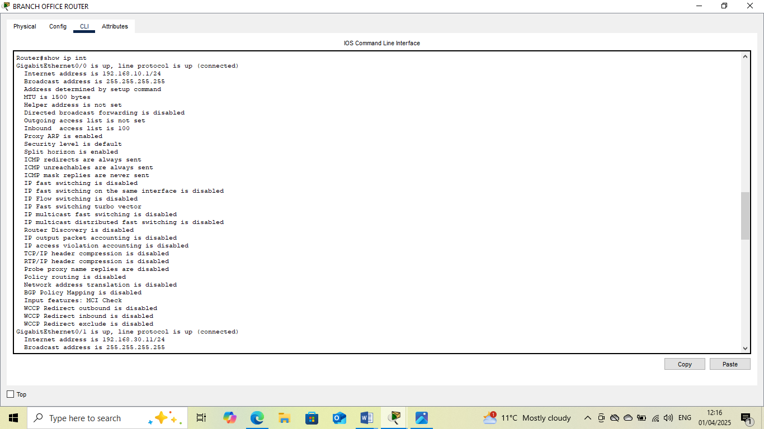

This Internship Task report was developed on [April,1,2025]

By:
[ samfelix15@gmail.com ]

